**Chapter: One Introduction of Research**

**Definition of Research:** Research is defined as a careful consideration of study regarding a particular concern or a problem using scientific methods. According to the American sociologist Earl Robert Babbie, “Research is a systematic inquiry to describe, explain, predict and control the observed phenomenon. Research involves inductive and deductive methods. Inductive research methods are used to analyze the observed phenomenon whereas, deductive methods are used to verify the observed phenomenon. Inductive approaches are associated with [qualitative research](https://www.questionpro.com/blog/qualitative-market-research/) and deductive methods are more commonly associated with [quantitative research.](https://www.questionpro.com/blog/quantitative-market-research/)

**Characteristics of Research**

1. A systematic approach is followed in research. Rules and procedures are an integral part of research that set the objective of a research process. Researchers need to practice ethics and code of conduct while making observations or drawing conclusions.

2. Research is based on logical reasoning and involves both inductive and deductive methods.

3. The data or knowledge that is derived is in real time, actual observations in the natural settings.

4. There is an in-depth analysis of all the data collected from research so that there are no anomalies associated with it.

5. Research creates a path for generating new questions. More research opportunity can be generated from existing research.

6. Research is analytical in nature. It makes use of all the available data so that there is no ambiguity in inference.

7. Accuracy is one of the important character of research, the information that is obtained while conducting the research should be accurate and true to its nature. For example, research conducted in a controlled environment like a laboratory. Here accuracy is measured of instruments used, calibrations, and the final result of the experiment.

**Scope & Objectives of Research**

**The research is a knowledge building process**

1. Helps to built a theory
2. Helps to solve a specific problem
3. Helps to develop policies
4. Helps to support decision making
5. Helps to get the research degree along with its benefits
6. Helps to provide service to the society
7. Helps to earn name to be famous and respected
8. Helps to get pleasure by doing a creative works

**Types of Research**

1.Descriptive vs. Analytical

2.Applied vs. Fundamental

3.Quantitative vs. Qualitative

4.Conceptual vs. Empirical

**1.Descriptive vs. Analytical**

•The major purpose of the descriptive research is description of the state of affairs as it exists; usually includes surveys and fact-finding enquiries. The main characteristic here is that the researcher has no control over the variables – he can only report what has happened or what is happening .Ex: survey methods to identify people’s preferences.

•In analytical **research** the researcher has to use facts or information already available and analyze these for critical evaluation.

**2.conceptual vs. Empirical**

•**Conceptual research** is related to some abstract idea or theory. Used by philosophers and thinkers.

•**Empirical research** relies on experience or observation alone; it is data based research;

**3.QuantitativevsQualitative Quantitative** research is based on the measurement of quantity – it is applicable to phenomena that can be expressed in terms of quantity.

Quantitative research methodology is another type of inquiry. It is a systematic investigation in social sciences and involves **mathematical**, **computational** and **statistical**techniques The aim of quantitative research method is to develop theories and mathematical model to study hypothesis. Any research methodology data that is enclosed in numeric form comes into the category of quantitative method.**Qualitative** research is concerned with qualitative phenomena – relating to or involving quality or kind. Ex.-motivation research. It is a method to inquire various researches based academic projects. Most often this methodology is applied in social sciences projects as well as market based research projects **Aim of the Qualitative Research Methodology**

The aim behind this method of inquiry is always to study human behavior. With the help of qualitative analysis technique, various reasons are studied to achieve an in depth consideration as why certain behavior appears in human being. More specifically, we can say that qualitative research methodology tells how and why certain decisions come forward in particular circumstances. So, the questions like **what**, **when** and **where** also matter but qualitative research method offers something beyond this concept.

**4. Applied vs. Fundamental**

Research can either be applied **(action)** research **or fundamental** (basics or pure).**Applied** research aims at finding a solution for an immediate problem facing society or an organization. Also known as practical or empirical or action research which is associated with a specific project or problem. Concerned to current activity or immediate practical situations of society. Aims at finding about a solution for immediate problem faced by a society and organization. Discovers what, how and why questions about policies, program and procedures of actual life. Also known as Action research Regular collection, presentation and interpretation of reliable data relating to the particular problem during the day to day activity of org. Conducted in order to get the continuous feedback and performance of the activity P V Young “Gathering knowledge that could aid in betterment of human destiny is termed as applied research.” Goode and Hatt “Applied research is one which can contribute new facts, can put theory to the test, may integrate previously existing theory.” Purpose: conducting this research is to acquire new skills or new approaches. To answer the practical questions about programmers and policies of organization Applied research focuses on analyzing and solving real-life problems. This type of research refers to the study that helps solve practical problems using scientific methods. This research plays an important role in solving issues that impact the overall well-being of humans. For example, finding a specific cure for a disease. whereas, **fundamental**Research is mainly concerned with generalizations and with formulation of a theory Also known as Pure, basic or theoretical research. Mainly concern with the generalization of theory. It is not concerned with solving any practical problems, policies Helps to discover the principle and laws. Tries to say why things happen in general. Social events, facts, thoughts, Business data, human behavior and natural phenomenon are dynamic. So every fact and theory on them also changes time to time. The study on such facts and changing phenomena is called basis research. It is base for applied research. According to P V Young “Getting knowledge for knowledge seekers is termed as basic research” According to K D Bailey “Basic research is values developing and testing theories and hypothesis that are intellectually challenging to the researcher but may or may not have practical application for present time or in coming future.” Purpose: conducting theoretical research is to search and advance the level of scientific knowledge which is the genesis of theory

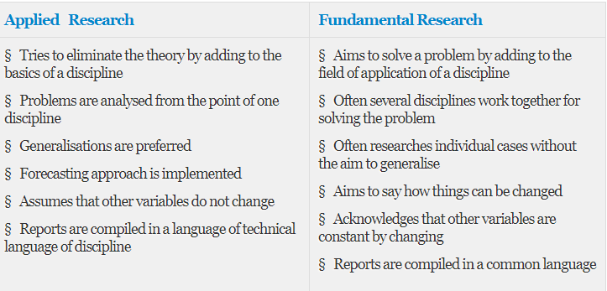

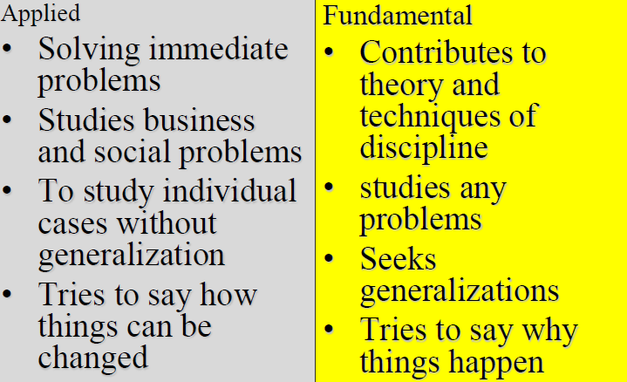

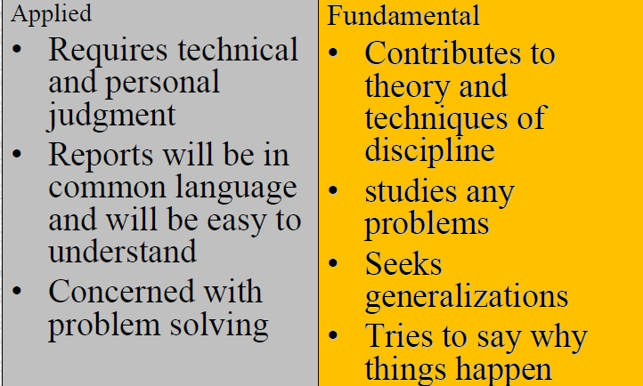

**Objective of Research**

Researches are carried out for a number of very good reasons. Some of the reasons are as follows **1.Theoretical objective**

i. To test and retest of real forms of social events

ii. To understand social changes.

iii. To make broad area of knowledge

iv. To search new facts and improving level of understanding

**Applied Objective**

i. To find out the causes and effect of changes social norms.

ii. To solve current social problems.

iii. To evaluate applied rules and regulations or plan and programs.

iv. To help administrative reforms

The purpose of research is to discover answers to questions through the application of scientific procedures. The main aim of research is to find out the truth which is hidden and which has not been discovered as yet. Though each research study has its own specific purpose, we may think of research objectives as falling into a number of following broad groupings:

1. To gain familiarity with a phenomenon or to achieve new insights into it (studies with this object in view are termed as exploratory or formulative research studies);
2. To portray accurately the characteristics of a particular individual, situation or a group(studies with this object in view are known as descriptive research studies);
3. To determine the frequency with which something occurs or with which it is associated with something else (studies with this object in view are known as diagnostic research studies);
4. To test a hypothesis of a causal relationship between variables (such studies are known as hypothesis-testing research studies).

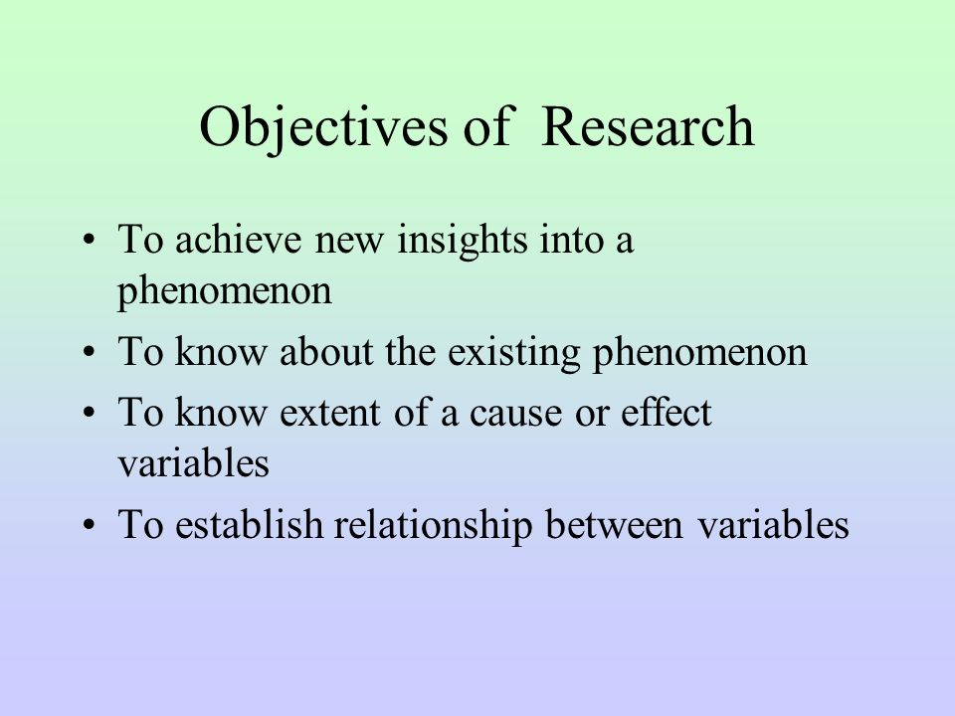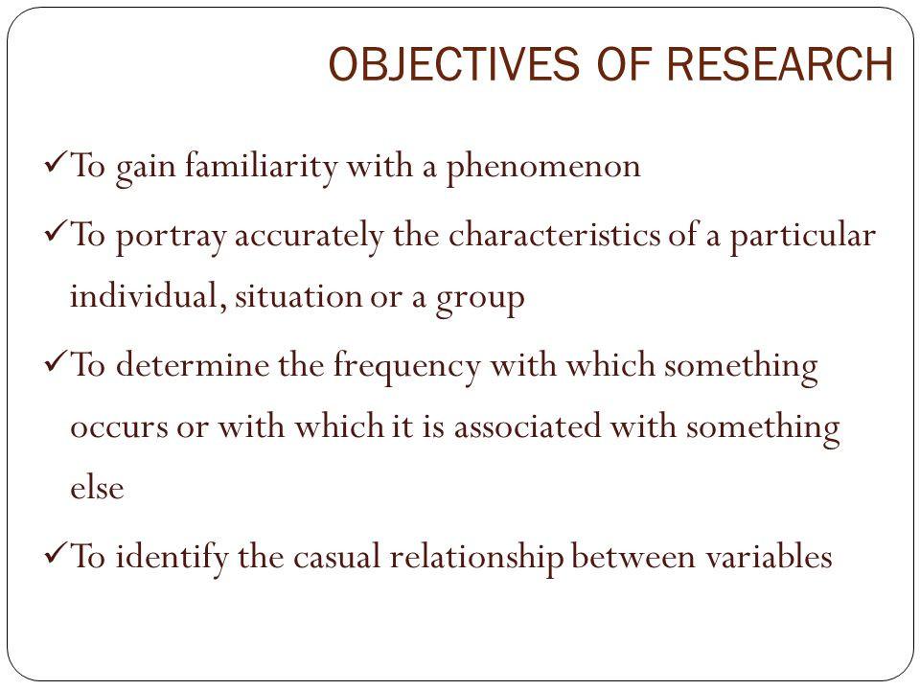

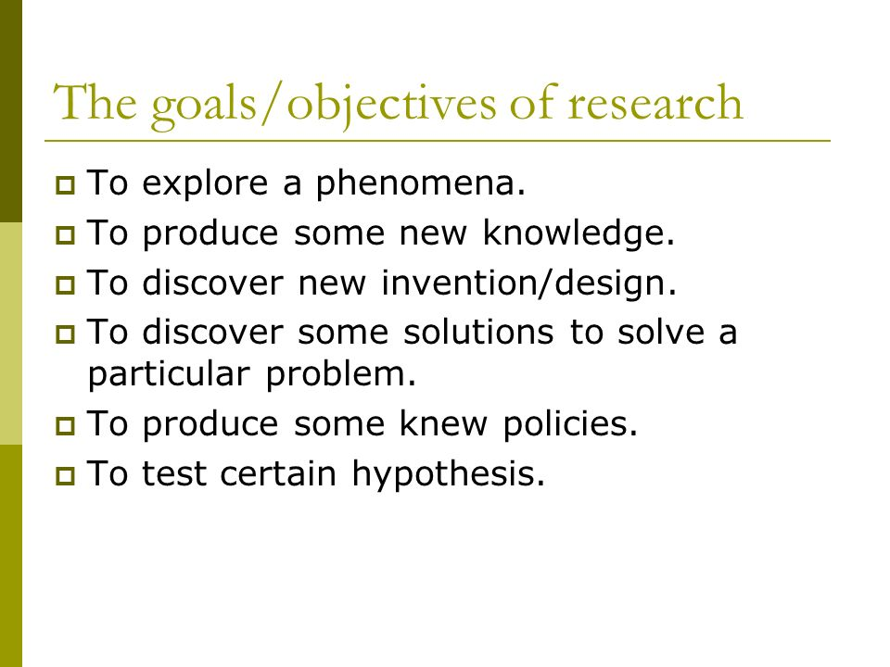

**6Ps of Research**

The aspects of research can be categorized as the 6p’s: purpose, products, process, participants, paradigm and presentation. All of these aspects need to be considered in any research project.

•Purpose:

The reason for doing the research, the topic of interest, why it is important or useful to study this, the specific research question(s) asked and the objectives set. Research without a purpose is unlikely to be good research. The reason of doing research

•Products:

The outcomes of research, especially your contribution to knowledge about your subject area. Your contribution can be an answer to your original researchquestion(s) but can also include unexpected findings. For example, you and the academic community might learn something about a particular research strategy as a result of your research. Your thesis, dissertation, conference paper or journal article is also a product of your research. For those research projects that involve design and creation, a new computer-based product or new development method could also be a product of your research. The outcomes of research, Your thesis, dissertation, conference paper or journal article is also a product of your research

•Process:

The sequence of activities undertaken in any research project. The process involves identifying one or more research topics, establishing a conceptual

framework (the way you choose to think about your research topic), the selection and use of a research strategy and data generation methods, the analysis of data and the drawing of conclusions, including recognizing any limitations in your own research .As explained already, the process should be carried out systematically if the research is to be accepted as rigorous. Process is the sequence of activities undertaken in any research project

•Participants:

* These include those whom you directly involve in your research, for example by interviewing them or observing them, and also those who are indirectly involved, such as the editors to whom you submit a research paper. It is important that you deal with all these people legally and ethically, that is, you do not doanything that might annoy them or cause them harm (physically, mentally or socially). You yourself as a researcher are also a research participant. As we shall see later, for some types of research, researchers are expected to be objective and remain largely unseen in the reporting of their research, whereas in other types of research the researchers are open about their feelings and how their presence influenced the other participants and the research situation. those whom you directly involve in your research,
  + **respondents**
  + **Researcher, agent**
  + **Reviewer etc**

•Paradigm:

* a pattern or model or shared way of thinking. Managers sometimes talk of the need for a ‘paradigm shift’ to mean that a new way of thinking is required. In computing, we talk about programming language paradigms, for example, a group of languages that share a set of characteristics, such as the object-oriented paradigm (for example, Smalltalk and C++).  Here we are connected with the philosophical paradigms of research. Any piece of research will have an underlying paradigm. Paradigm is a pattern or model.

**.**Presentation

* + Art of presenting the outcome
  + Interest of audience
  + Relevance of research work
  + Needs of organization

**Steps of Social Research**

#### **Step 1# Formulation of Research Problem**:

In real terms research begins with a problem which needs solution. Such a perception on the part of the researcher, first of all, falls within the general area of interest indicating to locate the problem either in the quest of some intellectual pursuit or for some practical concern, such as finding out a practical solution to a problem, evaluation of a programme in the light of new facts, gathering of relevant facts for social planning or even for policy making.While selecting a problem for research, the Social Scientists are likely to be influenced by their own personal values as well as the prevalent social conditions. As scientists differ with regard to their values and societies differ in respect of their preference of different spheres, the choice of topics in social research vary widely.

ADVERTISEMENTS:

As the general topic fails to provide the ability to examine the relevance of data, adopt the methods or to organize them, the need for formulation of a specific problem is always felt. This makes the goal of the researcher clear-cut. It not only guides the researcher in exploration, but also progressively sharpens the focus of questions by narrowing down the coverage like a pin­point. For example, if the general topic is compared with the base of a pyramid, the specific topic may resemble the apex of it.

In any case, formulation of a problem, arising out of theoretical situation or practical concern, is not an easy task, as it appears to be. In real terms it is a herculean task, so much so that even a scientist of the stature of Charles Darwin has gone to the length of saying that “Looking back, I think it was more difficult to see what the problems were than to solve them.”

As a problem involves some difficulty experienced by the investigator, the formulation of the problem should make its various components explicit in such a manner that it will justify the saying that “a problem well put is half solved” R.K. Merton has identified three important questions as the three principal components involved in the process of formulation of a problem in the field of research in soft sciences:

#### **Step 2# Review of Related Literature:**

Since an effective research is based on past knowledge, an investigator must always take advantage of the knowledge which have been preserved or accumulated earlier. It not only helps the researcher in avoiding duplication and formulating useful hypothesis, but also provides him with the evidence that he is familiar with what is already known and what is still unknown and untested in the field.

Review of related literature implies the analysis of the summary of the writings of recognized authorities and the earlier researches in the particular area. According to J.W. Best practically all human knowledge can be found in books and libraries. Unlike other animals…man builds upon the accumulated and recorded knowledge of the past.

In the words of C.V. Good “the keys to the vast store house of published literature may open doors to sources of significant problems and explanatory hypothesis and provide helpful orientation for definition of the problem, background for selection of procedure and comparative data so interpretation of results.”

The essentiality of the review of literature remains in the fact that it provides the researcher with an indication of the direction, updates information relating to researcher’s own problem, avoids the replication of the study of findings, provides the scope for analogy and formulation of hypothesis.

**The main objectives of review of related literature are:**

(i) To provide theories, ideas, explanations or hypotheses, which are likely to be helpful in the formulation of research problem?

(ii) To avoid overlapping studies,

(iii) To be a fertile source for formulating hypothesis,

(iv) To suggest the methods of data collection, procedures, to explore the sources of data and statistical techniques appropriate to the solution of the problem,

(v) To gather comparative data and findings of earlier researches which are of use in the interpretation of data and analysis of results?

(vi) To enable the investigator to gain expertise in his area of interest, and

(vii) To keep the researcher abreast of the most recent development in his area of activity.

**In order to survey the relevant literature, the investigator should follow the following principles:**

(i) At the outset, he should endeavor to obtain an overall view from the general source comprising those written materials which are more likely to provide the meaning and nature of the concepts and variables within the theoretical system.

(ii) Thereafter, the researcher should embark upon reviewing the empirical researches conducted in the concerned field. At this stage we make use the Handbook of Research, International Abstracts, etc.

(iii) The researcher must review the library material in a thorough and systematic manner.

(iv) He should take care to record the references with complete bibliographic data.

The main sources of literature which are of immense use for the researcher are books and text books; periodicals; encyclopedias; hand books, yearbooks and guides; abstracts; dissertations and theses; newspapers etc.

#### **Step 3# Formulation of Hypotheses:**

The next step in the process of research is the formulation of a tentative explanation of the problem in the form of a proposition wherever feasible. This tentative explanation or assumption or proposition refers to a conjectural statement of the relation between two or more variables and its tenability remains to be tested.

For formulating the hypothesis the researcher gathers information from several sources, such as existing theories, previous reports of research concerning analogous problems, information from knowledgeable persons, researcher’s own beliefs and insights. However, all studies do not begin with clearly formulated hypothesis.

Some are hypothesis testing studies and some others are hypothesis formulating studies. The exploratory studies are called hypothesis formulating studies because such researches end up with formulation of hypothesis. On the contrary, the hypothesis testing researches begin with clearly formulated hypothesis.

Notwithstanding the formulation of hypothesis at this level, the investigator needs to state the operational definitions of the concepts in order to translate the formal definitions, conveying the nature of the phenomenon, into observable referents.

In developing hypothesis, sociologists attempt to explain or account for the relationship between two or more variables. A variable is a measurable trait or characteristic that is subject to change under different conditions. For example, income, religion, occupation and gender can all be variables in a study.

If one variable is hypothesized to cause or influence another one, social scientists call the first variable as the independent variable and the second is termed the dependent variable. A correlation exists when change in one variable coincides with a change in the other. Correlations are an indication that causality may be present: they do not necessarily indicate causation.

#### **Step 4# Working Out Research Design:**

After formulating the research problem, reviewing the related literature and formulating hypothesis, wherever feasible, the researcher reaches the stage of embarking upon working out a design of study as he is guided by the maxim that “work must be planned, if it is to lead to discoveries”. A research design is the general blueprint for the collection, measurement and analysis of data incorporating what the researcher will have to perform from the formulating the tentative generalizations and their operational definitions to final analysis of data.By providing answers to various questions and acting as a standard and guidepost, it helps in carrying out research validly, objectively, accurately and economically and thereby ensures against its failure. Research designs vary according to the research purposes as well as from the point of view of realizable working procedure.

**As regards the research purposes, broadly speaking, there are four categories:**

(i) Exploration,

(ii) Description,

(iii) Diagnosis and

(iv) Experimentation.

**From the view point of realizable working procedure there are four parts of research design:**

(i) Sampling design, describing the different sampling methods to be used for selection of units for study,

(ii) Observational design, describing the way in which the observations are to be made,

(iii) Statistical design, dealing with the statistical techniques to be applied in the analysis and interpretation of data, and

(iv) Operational design, dealing with the specific techniques by which the entire operation of research is to be carried out. Thus it incorporates all the three designs mentioned above, such as the sampling, statistical and observational designs.

#### **Step 5# Defining the Universe of Study:**

The universe of study comprises all the items or individuals under consideration in any field of inquiry. In statistical terms, a ‘universe’ or ‘population’ refers to the aggregate of individuals or units from which a ‘sample’ is drawn and to which the results and analysis are to apply. The researcher may distinguish between the target population and survey population so as to clearly define the universe of study. The target population is that population for which the results of research are required.

On the contrary, the survey population implies those items or individuals which are actually included in the sampling frame from which the sample is drawn. However, in most sociological purposes such a distinction is not deemed to be significant. In any case, a complete population must be very explicitly defined in terms of elements, sampling units, extent and time.

#### **Step 6# Determining Sampling Design:**

As in practice a complete enumeration of all the items in the ‘universe’ is not possible under many circumstances, due to the requirement of a great deal of time, money and energy; the researcher embarks upon deciding the way of a selecting a representative sample which is popularly known as the sample design. It is a definite plan chalked out prior to actual collection of data for obtaining a sample from the universe. The sample must be representative and adequate.

**Broadly speaking there are three types of samples, such as:**

(i) Probability samples

(ii) Samples based on purposive or subjective or judgement sampling, and

(iii) Samples based on mixed sampling. Probability samples are drawn from the universe according to some laws of chance, based on scientific technique, in which each unit in the population has got some definite pre-assigned probability of being selected in the sample.

For a sample based on purposive or subjective or judgement sampling, units are drawn deliberately or purposely depending upon the objectives of investigation so as include only those important items which represent the universe truly. Units selected for a mixed sample are selected partly according to some probability laws and partly according to a fixed sampling rule which does not insist upon the use of chance. Some of the important types of sampling are: Simple random sampling. Complex random sampling, Stratified random sampling. Cluster and area sampling, haphazard or convenience sampling, quota sampling, judgement sampling etc.

#### **Step 7# Administering the Tools of Data Collection:**

Adequate and appropriate data are required for any standard research work. The data may differ considerably keeping in view the financial aspect, time and other resources available to the researcher. The researcher, while collecting data takes into consideration the nature of investigation, objective and scope of the inquiry, financial resources, available time and the desired degree of accuracy. That apart his own ability and experience also counts much in the collection of required data.

Secondary data are collected from books, journals, newspaper, reports of the earlier studies etc., whereas primary data are to be collected either through experiment or through survey. For examining the facts through hypothesis, the researcher, takes recourse to experiment for observing some quantitative measurements.

But, for the purpose of a survey, data may be gathered by observation, personal interviews, telephonic interviews, mailing of questionnaires and through schedules. For any particular survey he may administer one or more than one of the above methods, depending on the nature of study.

#### **Step 8# Analysis of Data:**

After completion of the collection of data, the researcher embarks upon the analysis of these data. This involves a number of operations such as establishment of categories, the application of these categories to raw data through coding, tabulation. Thereafter statistical inferences are drawn.

All these operations are very closely related to one another. At the outset, the researcher classifies the raw data into some usable categories on the basis of some purposes. At this stage coding operations is also done so as to transform the categories of data into symbols in order to make them amenable to be tabulated and counted. The researcher may also induct editing in order to improve the quality of data for coding.

Thereafter, in the post-coding stage, the classified data are put in the form of tables as a part of technical procedure either manually or through mechanical devices such as computers. Computers are generally used in large enquiries for the dual purposes of saving time and for making the study of large number of variables possible. While analyzing data, the researcher applies various well defined statistical formulae for the computation of percentages, coefficients, tests of significance, so as to determine with what validity data can indicate any conclusion.

#### **Step 9# Testing of Hypotheses:**

Sociological studies do not always generate data that confirm the original hypothesis. In many instance, a hypothesis is refuted and researchers must reformulate their conclusions. In behavioural sciences it is not possible to test several hypotheses directly. The social scientist can only test the research hypotheses by establishing some kind of sample of behaviour in order to observe it directly.

On the basis of these observable incidents, he determines whether or not those are consistent with the hypothesis so as to deduce their logical consequences. Thus an indirect test of the proposed hypothesis can only be made.

The research hypothesis is the prediction derived from the theory under test. It provides simply an inconclusive test. Actually a stronger test of logic is formed when a null hypothesis is rejected. The null hypothesis is a hypothesis of no difference, the rejection of which results in the acceptance of the alternative hypothesis. The alternative hypothesis is the operational statement of the researcher’s research hypothesis. In behavioural science research the rejection or acceptance of a null hypothesis is based on 0.05 or .01 alpha level of significance.

The statisticians have developed various tests like chi-square test, t-test, F-test for the purpose of testing the hypothesis. In the studies, where no hypotheses are there to begin with, the generalizations will serve the basis of formulation of hypothesis which may be tested by subsequent researcher in future.

#### **Step 10# Generalization and Interpretation:**

After the hypothesis is tested and found valid, it becomes possible on the part of researcher to reach the stage of generalization, which may be construed to be the real value of research. This is only possible in case of hypothesis-testing studies. But in the hypothesis formulating studies where the researcher has no hypothesis to begin with, he may seek to interpret his findings. In other words, he may seek to explain the findings of his research on the basis of some theoretical framework, which may probably raise some new questions for further researches.

#### **Step 11# Reporting the Research:**

Research report is the end product of a research activity which gives an account of a long journey on the path of finding a new knowledge or modified knowledge. Writing a research report is a technical task as it requires not only skill on the part of the researcher but also considerable effort, patience and penetration, an overall approach to the problem, data and analysis along with grasp over language and greater objectivity, all springing from considerable thought.

**The purposes of research report are:**

i. transmission of knowledge;

ii. presentation of findings,

iii. examining the validity of the generalization, and

iv. Inspiration for further research.

**Alternative**

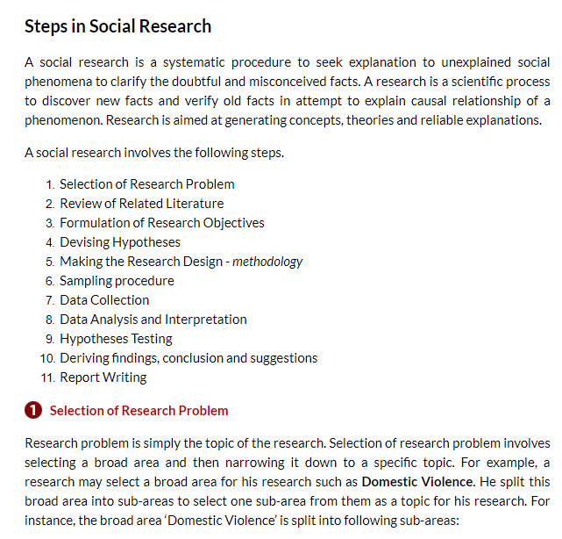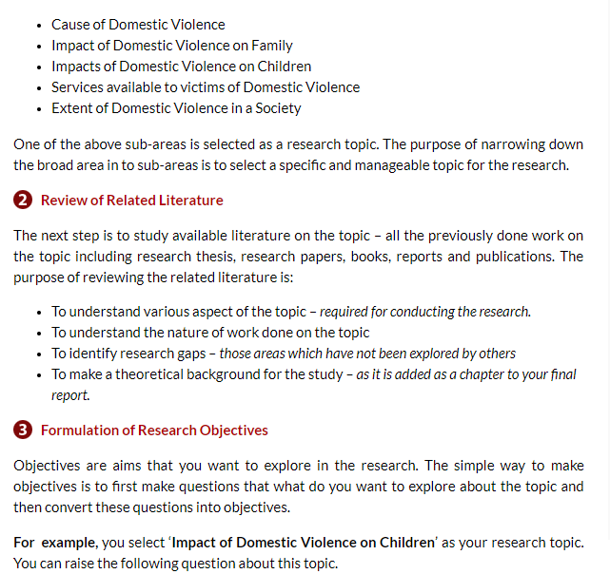

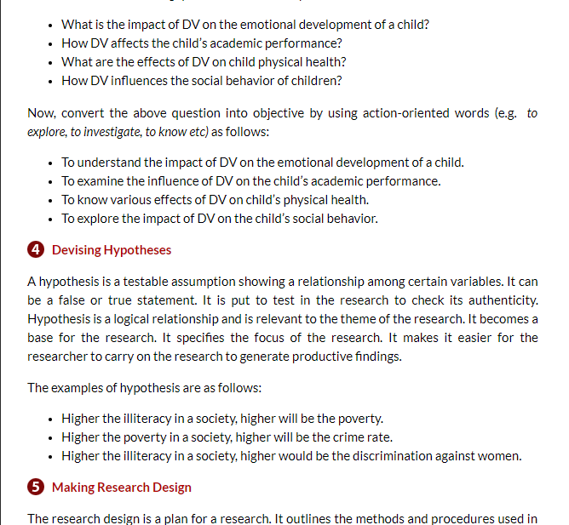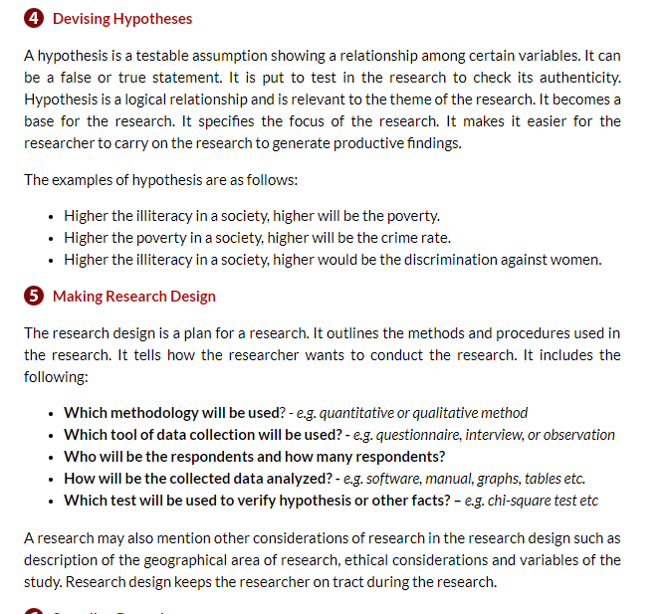

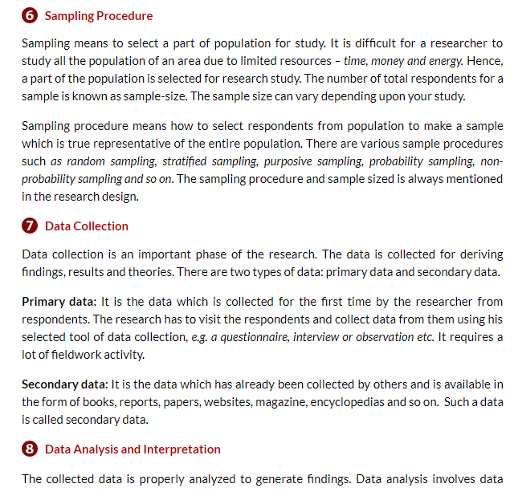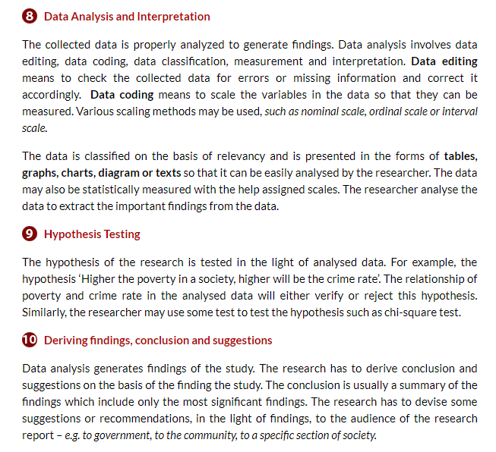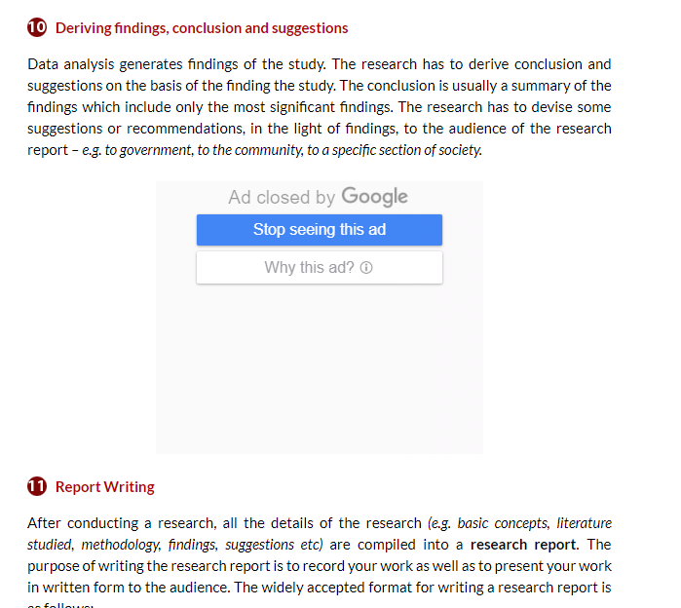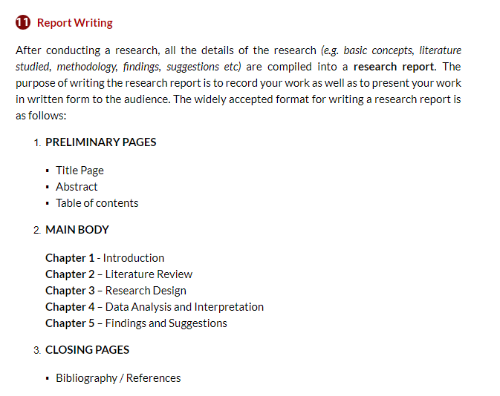

**Significance of Research in Engineering**

* Mostly in the field of engineering research is applied research concerned with

1. Developing new products and processes

2. Improving existing products and process

3. Finding new uses for existing products

4. Solving the problem related to different field of engineering